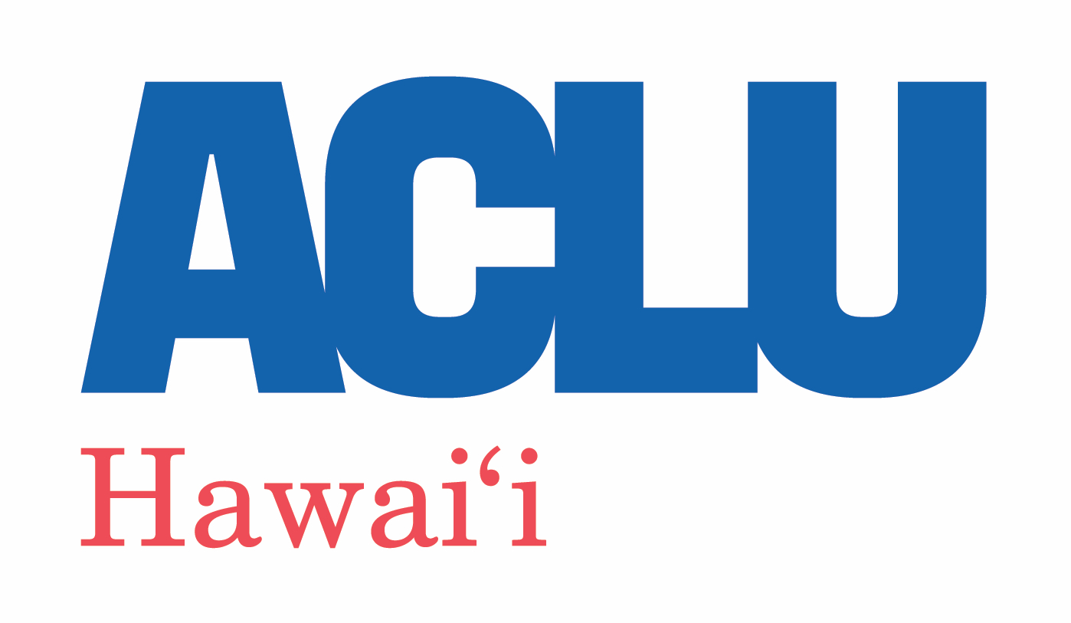

June 18, 2021

VIA CERTIFIED MAIL AND ELECTRONIC MAIL

Chair Shannon L. Alivado,
Vice Chair Gerard “Jerry” Gibson,
Commissioner Michael Broderick,
Commissioner Doug Chin,
Commissioner Carrie K.S. Okinaga,
Commissioner Richard Parry,

c/o Executive Officer Honolulu Police Commission
1060 Richards St., Suite 170
Honolulu, HI 96813 policecommission@honolulu.gov

Re: Ten Questions for the Next Chief of Police

Dear Chair Alivado, Vice Chair Gibson, and Honolulu Police Commissioners,

The appointment of a new chief of police marks a turning point for the City and County of Honolulu as it is a unique opportunity for the leadership of the Honolulu police to regain the trust of the people they serve. We said the exact same thing when we wrote to the Commission in 2017 as you began the search for a new police chief after the departure of former Chief Louis Kealoha. It is only more true today.

We recently observed the one-year anniversary of the murder of George Floyd by a police officer. We are still grieving the murder of Breonna Taylor who was killed by police officers during a no-knock raid while she slept–she would have celebrated her 28th birthday this month. In 2020 alone, police nationwide killed 1,127 people. There were only 18 days that year in which a police officer did not kill someone. Last year over 10,000 people marched to the Hawai‘i State Capitol to protest police violence. It has only been a matter of weeks since the killings of two people of color—Iremamber Sykap and Lindani Myeni—by Honolulu Police Department (HPD) officers in situations that have provided far more questions than answers, including with the release of additional footage in the killing of Mr. Myeni. We have seen local report after report after report after report about disparities in use of force and arrests based on race, right here in Hawai‘i. Former Honolulu Police Chief Kealoha has just begun his prison sentence for corruption. But he still hasn’t taken responsibility for his crimes as he now denies committing them, even though he’d previously admitted to them in federal court. Police Chief Raybuck on Kaua‘i was reprimanded and forced to apologize after making openly racist statements. Former Police Chief Faaumu on Maui has been investigated for a hit and run. Former Chief Ballard herself has said that hundreds of HPD officers abused overtime, the city council is calling for an audit, and a federal investigation of the police regarding how they spent federal CARES Act funding is ongoing. And just this week, one police officer has been charged with murder and two more have been charged with attempted murder for the killing of Iremamber Sykap. And yet despite all this, when Governor Ige signed legislation last year to finally provide some transparency into officer misconduct, SHOPO immediately went to court to try to stop it.

For all these reasons, and to aid the Commission in making the important decision of who will lead HPD in the coming years, we are writing to request that you pose ten timely and relevant questions about civil liberties to all candidates for the position of police chief. The answers to these questions will hopefully inform the Commission’s decision making and help define HPD’s relationship to the public moving forward.

In creating HPD, the Charter for the City and County of Honolulu provides that it is establishing “a system of law enforcement which shall be based on due regard for the constitutional rights of all persons, which shall promote the highest possible degree of mutual respect between law enforcement officers and the people of the city, and which shall provide for the expeditious apprehension of those who violate the law.” Revised Charter of the City & County of Honolulu (the “Charter”) § 6-1602. Thus, the Charter explicitly provides that the purpose of HPD is not just—or even primarily—to judiciously enforce the law, but to do so with due regard for constitutional rights and respect for the people of Honolulu.

The chief of police is the administrative head of HPD and, as such, is tasked with carrying out the Charter’s mission of preserving public peace while respecting the public’s constitutional rights. Neither the Charter nor the Revised Ordinances of Honolulu lay out with any specificity how the chief of police must carry out these goals, leaving the promulgation of rules and regulations, and the training, supervision, and appointment of personnel primarily to the chief of police. Charter § 6-1604. Given that HPD has almost exclusive authority and discretion on the lawful use of force on O‘ahu, carrying out these duties is a solemn responsibility.

The general public in Honolulu does not have a direct say in selecting the chief of police.
Instead, as an added layer of independence, this responsibility rests with the Commission, which can appoint and remove the chief of police for any reason. Charter § 6-1603. Despite Mayor Blangiardi suggesting he will have a “very big say” in determining the identity of the next police chief, the City Charter does not provide for the Mayor having any formal role in this selection either. This means the chief of police serves at the Commission’s pleasure and that you are ultimately responsible for ensuring, on behalf of the public, that the chief of police is properly carrying out HPD’s mission of maintaining the peace and respecting the constitutional rights of the people of the City and County of Honolulu.

As our community faces enduring challenges, the role of the new chief of police in helping or hurting each individual’s fundamental rights under the Hawaiʻi and United States constitutions cannot be overstated. The new chief will need to ensure that use of force does not continue to disproportionately impact our Native Hawaiian, Pacific Islander, and Black community members. The new chief will need to set a new course for transparency within the police department, including how and how quickly footage from body cameras will be made public. The new chief will play a key role in guaranteeing the right to due process, the right to counsel, the right to remain silent, and the right to be secure against unreasonable searches and seizures. The new chief will need to ensure the people’s right of free speech and the right to protest are respected. As military-grade equipment and more intrusive surveillance tools become available, the new chief will decide whether and how HPD should use these tools. The new chief of police will set the culture and enforcement priorities of HPD: thus, the new chief will ultimately be either part of the problem or part of the solution in addressing prison overcrowding and the overrepresentation of people who are Native Hawaiian, Pacific Islander, Black, houseless, indigent, or otherwise marginalized in our correctional system.

Finally–and critically–the new chief must be able to admit when HPD has done things wrong and acknowledge where there are opportunities for improvement. This would be a sign of strength, not weakness. For example, denying disparities in use of force and arrests based on race, despite statistics from HPD itself showing these exist, hurts both the department and the community. The new chief must set a new direction for HPD in admitting fault and pledging improvement.

For these reasons, the appointment of a new chief of police is a powerful moment for rebuilding the trust in HPD’s leadership and mission. To ensure the next chief of police understands and is committed to respecting civil rights, we respectfully request that the Commission pose the following ten questions to all candidates for the position:

- Do you acknowledge that systemic racism and implicit bias exist in the criminal legal system in Hawai‘i, including in policing, and that discrimination based on race occurs in Hawai‘i, including in policing?

- What is your plan to eliminate racial disparities in policing in Hawai‘i, especially with respect to people who are Native Hawaiian, Pacific Islander, Black, people with disabilities, people who are houseless, and other groups who are disproportionately impacted by police compared to their population numbers?

- Do you support an independent prosecuting unit for cases where people are killed by police, sexually assaulted by police, the victims of excessive force by police, and other police misconduct cases?

- Are you committed to being part of the solution to end mass incarceration and overcrowding in O‘ahu’s jails and prisons by supporting criminal legal system reforms that reduce incarceration, decriminalize poverty, focus on rehabilitation, and reduce recidivism? Examples of these types of reforms include, among other things, Law Enforcement Assisted Diversion (LEAD), the Department of Health Hawai‘i CARES program, and the Crisis Assistance Helping Out On The Streets (CAHOOTS) program that is being used in Oregon.

- Will you implement a robust conflict-of-interest policy (and related training, supervision, and disciplinary protocols) that will apply to all police officers in the execution of their duties?

- Are you committed to ensuring that the public knows how the police department functions, including through improved and disaggregated data collection in electronic form and the adequate disclosure and reporting of all incidents involving the use of force, the use and deployment of surveillance technology, the use of body cameras, and confirmed incidents of police misconduct?

- Do you commit to developing and implementing a community engagement plan that includes communities of color, immigrant community-based organizations, and criminal legal reform advocates in the development of your first 100-day plan?

- Are you committed to guaranteeing the right of free speech and the right to protest by taking meaningful actions to protect these rights? Meaningful actions would include issuing policies, training law enforcement, creating oversight, and holding officers accountable so that the police will not interfere with these rights in public places. Further meaningful actions include never engaging in mass arrests, never using surveillance technology on protesters, never using military-grade equipment to control crowds, always respecting the public’s right to record the police, and working to de- escalate tensions between protesters and the police.

- Are you committed to guaranteeing the right to due process, the right to counsel, the right to remain silent, and the right to be secure against unreasonable searches and seizures by taking meaningful actions to protect these rights? Meaningful actions would include issuing policies, training law enforcement, creating oversight, and holding officers accountable so that the police will not: stop someone without reasonable suspicion; arrest someone without probable cause; search someone or their property without a warrant (whenever such warrant is required); or fail to inform someone of their Miranda rights. Further meaningful actions include being honest and truthful in court, following proper procedures in taking law enforcement actions, and turning over exculpatory evidence to the prosecuting attorneys so that it can be disclosed to the defense.

- Are you committed to curbing the excessive militarization of the police force by imposing meaningful restraints and adopting best practices on the use of SWAT and similar tactical teams, ensuring that there is civilian oversight over the acquisition of military style weapons and vehicles, and eliminating the use of no-knock or quick-knock raids that often result in harm to both civilians and police officers?

While not exhaustive, these questions will hopefully begin a conversation about the role of HPD in protecting civil rights that will help the public regain their trust in HPD’s leadership and mission. We also hope you will take into consideration not only the candidates’ answers to these questions, but also their past actions and proven commitments to protecting civil liberties. In our experience, actions speak louder than words.

The ACLU of Hawaiʻi remains a resource to the Commission for any additional information you may need on these matters, including model policies, best practices, and procedures. We will continue to monitor the police in our role to defend and preserve the rights and liberties guaranteed by our state and federal constitutions, and appreciate your attention to the important issues raised in our request.

Sincerely,
Joshua Wisch
Executive Director
ACLU of Hawaiʻi

The mission of the ACLU of Hawaiʻi is to protect the fundamental freedoms enshrined in the U.S. and State Constitutions. The ACLU of Hawaiʻi fulfills this through legislative, litigation, and public education programs statewide. The ACLU of Hawaiʻi is a non-partisan and private non-profit organization that provides its services at no cost to the public and does not accept government funds. The ACLU of Hawaiʻi has been serving Hawaiʻi for over 50 years.

https://mappingpoliceviolence.org
“Racial disparities emerge in HPD enforcement of stay-at-home violations,” June 29, 2020 on Hawai‘i Public Radio.
“HPD Chief says there’s less racial bias in Hawai'i. She’s wrong,” June 29, 2020 in Civil Beat.
“Honolulu Police Commission questions disparities in use of force,” February 7, 2021 in the Star Advertiser.
“HPD’s use of lethal force is near the US average. But there’s far more to the story,” June 1, 2021 in Civil Beat.
“Former Honolulu police chief Louis Kealoha begins prison sentence in Oregon,” June 2, 2021 on KHON2 news.
“Ex-HPD chief begins 7-year prison sentence for crimes he now denies,” June 1, 2021 on Hawai‘i News Now.
“Kaua‘i police chief suspended for 5 days following alleged racist comments,” April 16, 2021 on Hawai‘i News Now.
“Maui police chief involved in hit-and-run incident,” November 18, 2020 on KITV4.
“In internal video, police chief says 263 officers abused overtime policy,” February 27, 2021 on Hawai‘i News Now.
“Feds examining Honolulu police CARES spending on ATVs, robot dog,” March 9, 2021 in Civil Beat.
“A Honolulu officer is charged with murder in the shooting of a 16-year old,” June 16, 2021 on National Public Radio.
“SHOPO tries again to keep officer misconduct secret,” November 12, 2020 in Civil Beat.
“How Honolulu will select is next police chief,” April 19, 2021 in Civil Beat

